Data Structure (IT245 – CS240 – DS240)
Discussion Board Due to 5 – 3 – 2026

التعليمات:
اولا اكتب ردك الأساسي:
- ادخل على Discussion Board، واضغط على "إنشاء موضوع"(Create Thread)
- اختر سؤالاً واحداً من الأسئلة بملف الـ Discussion Board وأكمل جميع الخطوات المطلوبة.
- يجب عليك إرفاق صورة (او صور) أصلية التقطتها بنفسك.اشرح وجهة نظرك بتفصيل، وركز على النقاط اللي طلبت.
- لا تنسَ: لازم يكون كلامك من عندك، مو منسوخ من النت!
ثانيا رد على زملائك:
- اقرأ مشاركات زملائك، واكتب رد واحد على الأقل.
- يجب أن يتضمن ردك واحدًا على الأقل مما يلي:
• تحليل أو نقد كيفية استخدام الـ data structure المستخدمة من زميلك
• اقتراح تحسين أو data structure بديلة
• الإشارة إلى تفصيله مفقوده أو افتراض غير واضح
- ممنوع الردود السريعة زي "كلامك صح" أو "مرة حلو" بدون شرح!
موعد التسليم:
آخر موعد لإرسال مشاركتك وردودك على زملائك: "الخميس، 5 مارس 2026، الساعة 11:59 بالليل."
شروط النجاح:
المشاركة الأصلية (الرد الأساسي):
- يجب عليك إرفاق صورة (او صور) أصلية التقطتها بنفسك.اشرح وجهة نظرك بتفصيل، وركز على النقاط اللي طلبت
- الدرجة: 3 درجات.
الردود على الزملاء:
- اكتب رد واحد على الأقل من مشاركات زملائك.
- الدرجة: درجة.
تحذير مهم:
- ممنوع النسخ من النت! إذا نسخت كلامك من أي موقع أو مقال، راح تتحصل على صفر مباشرة.
- أكتب بأسلوبك الخاص، حتى لو كان بسيط. المهم التفاعل النقدي.
نصيحة أخيرة:
- لا تؤجل المشاركة لآخر يوم!
- إذا واجهتك مشكلة، تقدر تسالني على الجروب.
أمثلة عن المشاركة:
لو قمت باختيار السوال الاول للاجابه عليه فقط فماذا تفعل:
١. ابحث عن Stack حقيقي في محيطك أمثلة: (أوراق، كتب، أطباق، غسيل، أغراض في حقيبة)
٢. التقط صورتين أصليتين:
- الصورة ١: الـ Stackفي حالته الطبيعية
- الصورة ٢: بعد إزالة بعض الأغراض للوصول إلى شيء تحتها
ما يجب كتابته:
• اذكر اسم غرضين على الأقل يظهران في الصورتين.
• اشرح كيف تسبب ترتيب "آخر ما يدخل أول ما يخرج" في صعوبة أو جهد إضافي في هذه الحالة.
• اشرح لماذا لا يزال هذا الـ Stackموجود رغم أنها غير فعالة.

مثال رقم 1:


The photos show a physical stack of books placed one on top of another. Among the visible items in the stack are a thick brown hardcover book at the bottom and a blue-covered book placed above it. Other books with beige and dark leather covers are also clearly visible, forming a vertical pile.
In this situation, the Last In, First Out (LIFO) rule caused noticeable difficulty. The book I needed was the brown hardcover book at the bottom of the stack. Because several books were placed on top of it later, I had to remove all the upper books one by one to reach it. This required extra effort and time, especially since the books are heavy and must be handled carefully to avoid damage. After retrieving the needed book, I also had to restack the removed books, which added unnecessary work. This perfectly demonstrates how LIFO can be inefficient when the required item is not the most recently added one.
Despite this inefficiency, this stack still exists for practical reasons. Books are often stacked due to limited shelf space, ease of temporary storage, and the natural habit of placing newly used books on top. Additionally, stacking books vertically helps keep them organized in one place and prevents them from being scattered. In many real-life situations, convenience and space management are prioritized over efficiency, which explains why such stacks continue to be used.
لو كنت طالب اخر وشوفت الـ Post ده وكنت عاوز اعمل Comment عليه فده شكل الـ Comment
As another student, I think this is a clear and relevant real-life example of a LIFO stack, and the connection to the photos is well explained. However, one point that could be critiqued is that the stack is treated as unavoidable, while in reality the inefficiency comes more from how the books are stored rather than from the books themselves.
An improvement could be to use an alternative data structure, such as a queue-like arrangement or indexed shelving, where books are placed side by side or ordered vertically on a shelf. This would allow direct access to any book without removing others, reducing time and physical effort. From a data structures perspective, this would be closer to random access rather than strict LIFO behavior.
مثال رقم 2:
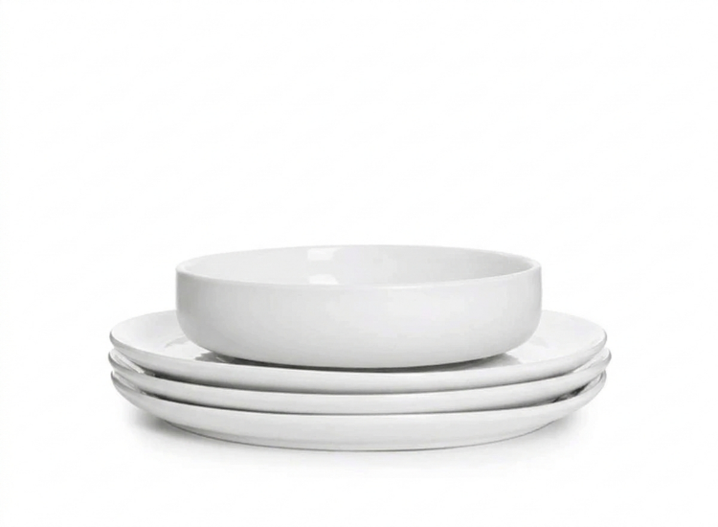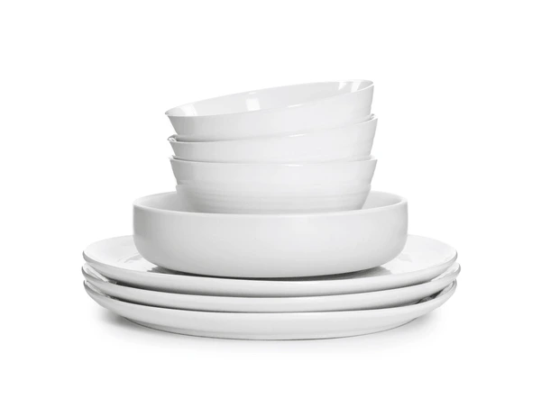
For this activity, I used a stack of kitchen dishes from my home environment to demonstrate the Last In, First Out (LIFO) principle.
In the first photo, the stack appears in its normal state. At the bottom, there are several white ceramic plates, above them a larger serving bowl, and on top of that a number of smaller bowls stacked neatly. The items are arranged vertically inside a cabinet, forming a clear physical stack. The order of placement follows a natural routine: plates are placed first after washing, then larger bowls, and finally smaller bowls on the top.
In the second photo, I removed the smaller bowls in order to reach the large serving bowl underneath. This action directly demonstrates the LIFO rule. The last items that were placed (the small bowls) had to be removed first before I could access the serving bowl. Although I did not need the small bowls at that moment, I was forced to move them temporarily. After retrieving the serving bowl, I had to return the smaller bowls back to their original position.
This situation created extra effort and slight inconvenience. The difficulty did not come from the weight or number of items, but from the restriction imposed by the stack structure itself. Direct access to middle or bottom elements is not possible without removing the top elements. This is exactly how stack operations work in programming: to access an older element, we must “pop” the more recent ones first.
Despite this inefficiency in access, the stack arrangement continues to exist in daily life for practical reasons. First, it saves space, which is essential in kitchen storage areas. Second, it keeps similar items organized and visually tidy. Third, it provides a simple and intuitive method of storage without requiring complex organization systems. Therefore, while stacks may not be optimal for quick access to lower elements, they are highly efficient for space management and structural simplicity.

لو كنت طالب اخر وشوفت الـ Post ده وكنت عاوز اعمل Comment عليه فده شكل الـ Comment
Your example clearly demonstrates the LIFO principle, but one important detail seems unclear: was the stack organized based on frequency of use or simply based on available space? If the large serving bowl is needed frequently, then using a stack in this way may not be the most efficient structure because it requires repeated removal of the top items.
An alternative improvement would be reorganizing the dishes so that frequently used items are placed on top, or arranging them side by side on a shelf. This would allow easier direct access and reduce the extra effort caused by the strict LIFO order.

لو قمت باختيار السوال الثاني للاجابه عليه فقط فماذا تفعل:
المطلوب:
1. استخدم أربع sticky notes أو قطع من الورق لإنشاء linked list
2. ضع كل sticky note في مكان مختلف في غرفتك.
3. على كل sticky note، اكتب:
• القيمه التي تخزن بها
• موقع الملاحظة التالية
4. التقط صورة أصلية لكل Node، بما في ذلك الـ Head.
ما يجب كتابته:
• صف linked list خطوة بخطوة، بدءًا من الـ Head.
• اشرح معنى NULL في مثالك (إن وُجد)، أو اشرح لماذا لا نحتاج إلى NULL.
• اشرح سببًا ماديًا واحدًا يجعل الـ linked list أفضل من المصفوفة في غرفتك.
يجب أن يشير شرحك بوضوح إلى العناصر والمواقع الموضحة في صورك.

مثال:
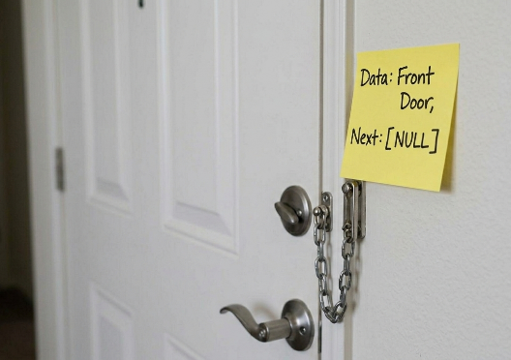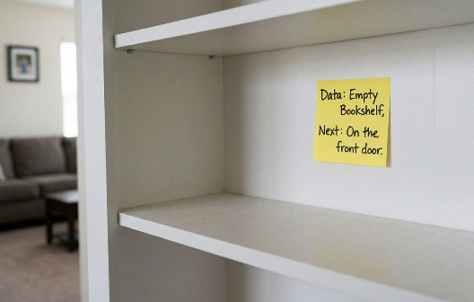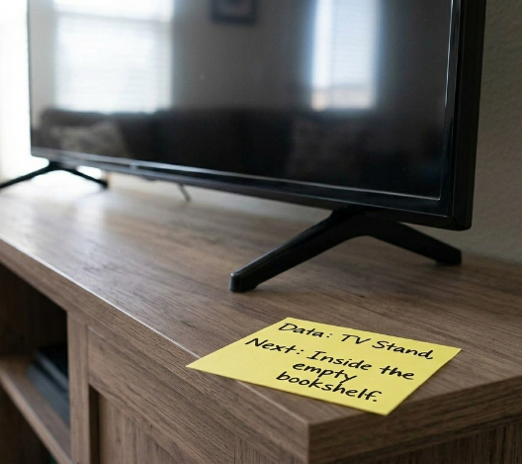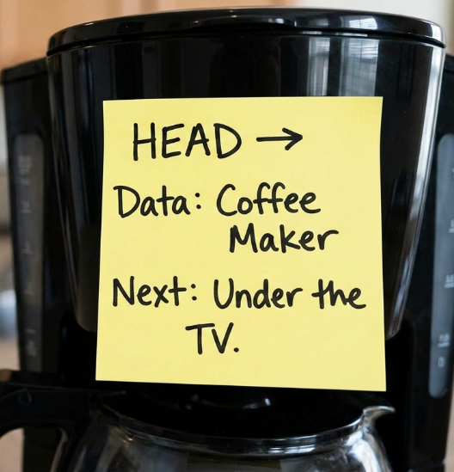

Step-by-step description starting from the Head:
- Head node: The first sticky note is attached to the coffee maker. This node is labeled as the Head. The data stored in this node is Coffee Maker, and the pointer (Next) clearly directs to Under the TV. This means the linked list starts at the coffee maker.
- Second node: The next sticky note is placed under the TV, on the TV stand. The data in this node is TV Stand, and its pointer indicates that the next node is Inside the empty bookshelf.
- Third node: The third sticky note is attached inside the empty bookshelf. The data stored here is Empty Bookshelf, and the pointer directs to On the front door.
- Fourth node (last): The final sticky note is placed on the front door. The data is Front Door, and the pointer is written as NULL, indicating the end of the linked list.
Meaning of NULL in this example:
In my linked list, NULL means that there is no next node after the front door. It represents the termination of the list, like how the last node in a linked list in programming points to NULL to show that traversal should stop.
Why linked list works better than an array in my room:
A linked list works better than an array in my room because the objects (coffee maker, TV stand, bookshelf, and front door) are physically far apart and not arranged in a fixed sequence or line. An array requires elements to be stored contiguously, which is unrealistic in a real room layout. With a linked list, each object can be placed anywhere, and the logical order is maintained through pointers (locations written on the notes), not physical proximity. This flexibility reflects why linked lists are useful when memory or space is non-contiguous.

لو كنت طالب اخر وشوفت الـ Post ده وكنت عاوز اعمل Comment عليه فده شكل الـ Comment
I think this is a clear and creative use of a linked list concept, especially how each physical object represents a node with both data and pointer. The progression from the coffee maker to the front door makes the traversal easy to understand and closely matches how a singly linked list works in theory. One point that could be improved is that the post does not explicitly mention whether this is a singly linked list or if it could be extended to a doubly linked list. For example, adding a “Previous” reference on each sticky note (except the Head) could strengthen the explanation and show how backward traversal would work in a real environment.

